**Lab 7 : Write a program to implement Hadoop/MapReduce in .NET.**

**Theory:**

**Hadoop:**  Hadoop is an open-source tool that helps store and process large amounts of data across many computers. It splits the data into smaller parts and stores them on different machines in a cluster, making it easier to manage and analyze big data. Hadoop has two main parts: HDFS (Hadoop Distributed File System), which stores the data, and MapReduce, which processes the data.

**MapReduce:** MapReduce is a method used to process large datasets in a simple and efficient way. It works in two main steps: the Map Step and the Reduce Step. In the Map Step, the data is divided into smaller pieces and turned into key-value pairs. These key-value pairs make it easier to work with the data in smaller, manageable chunks. Then, in the Reduce Step, the small pieces of data are combined and processed to produce the final result. This two-step process allows MapReduce to handle and analyze large volumes of data quickly and effectively, making it ideal for big data tasks.

**Source Code:**

using Microsoft.Hadoop.MapReduce;

using System;

using System.Collections.Generic;

using System.Linq;

namespace MyApp

{

class Program

{

static void Main(string[] args)

{

var testListForMap = new List<int> { 10, 12, 13, 14, 15, 16, 17, 18, 19, 20 };

var mapList = Map<int, int>(x => x + 2, testListForMap);

Console.WriteLine("Map Function Output");

mapList.ToList().ForEach(i => Console.Write(i + " "));

Console.WriteLine();

Console.ReadKey();

Console.WriteLine("******************************************");

var testListForReduce = new List<int> { 10, 12, 13, 14, 15, 16, 17, 18, 19, 20 };

Console.WriteLine("Reduce Function Output");

Console.WriteLine(Reduce<int, int>((x, y) => x + y, testListForReduce, 0));

Console.ReadKey();

}

static IEnumerable<TResult> Map<T, TResult>(Func<T, TResult> func, IEnumerable<T> list)

{

foreach (var i in list)

yield return func(i);

}

static T Reduce<T, U>(Func<U, T, T> func, IEnumerable<U> list, T acc)

{

foreach (var i in list)

acc = func(i, acc);

return acc;

}

}

}

**Output:**

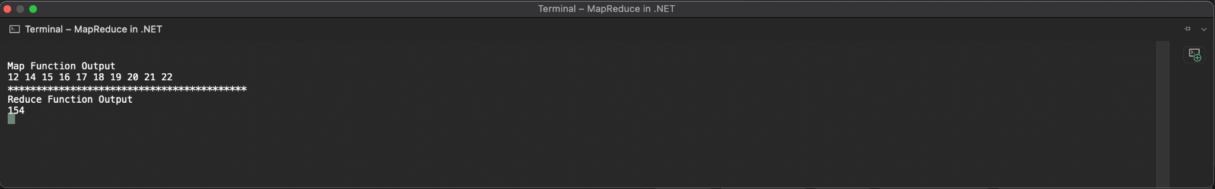

**Conclusion:**

In this lab of we are familiar with the concept of MapReduce, Hadoop programming in C# .NET.